|  |
| --- |
| INB348 |
| OutGoer |
| Braydon Cohn & Jordan Hennell |

|  |
| --- |
|  |

**Executive Summary**

The name of the application is “OutGoer”. The application is specifically built around providing users with a discussion board that lets users discuss various different topics of interest to tourists that visit the city of Brisbane. These topics would include food and dining, the Brisbane nightlife, tourist attractions and tours, and general information for travellers coming to the city. The users would be able to start topics in the sub-forums dedicated to each of these subjects. The intended users of the application would be generally tourists that know how to read and speak English at a conversational level.

**Reviews Of Other Applications**

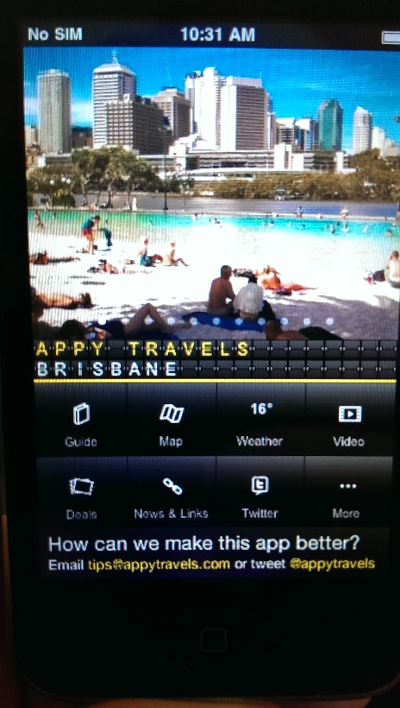**Brisbane Travel Companion – By Appy Travels**

*Brisbane Travel Companion* is a free travel information app available on Android and iOS. It aims to serve as a complete travel companion (as the name suggests), providing the user with maps, videos, weather and anything they might need information about on a holiday. While this version of the app is for Brisbane, there are also versions for many other cities and areas around Australia and the US (with more being added frequently).

The test device for this app was an iPhone 3 running iOS 4.2.1 (screen capturing was not possible, through no fault of the app, so screenshots were done with a separate camera).

**Features**

* Guide
* Map
* Weather
* Video
* Deals
* News & Links
* Twitter
* Currency Converter
* Phrases
* Nearby Destinations

**Guide**

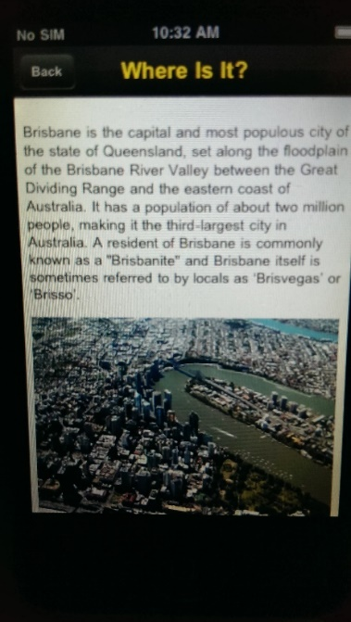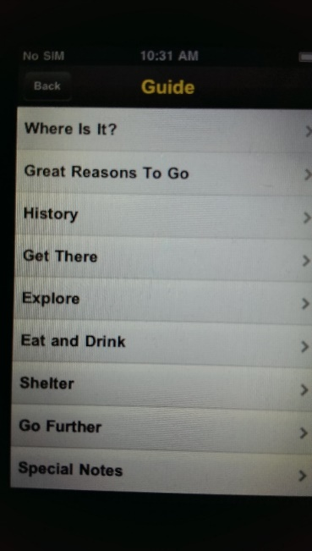Most of the functionality that Brisbane Travel Companion offers up is in the guide section. It contains information on attractions, restaurants, bars and accommodation in Brisbane. If the user sees somewhere they may want to go, perhaps a café or market, they can select the location to bring up more information (including address, description and external website) as well as a map for navigation. This appears to be a very useful feature for a traveller as they can not only see information on a smorgasbord of venues, but view the location on a map (see Map sectionbelow).

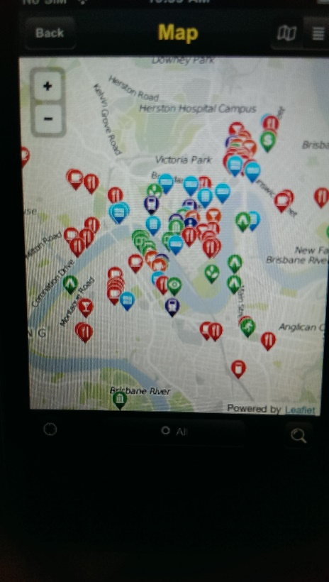

**Map**

Brisbane Travel Companion also features a mapsection. This can be seen as the primary navigation tool for the app. It displays all locations a tourist may want to visit, categorised by type (accommodation, attractions, etc.), on a graphical map or in a textual list. More information on a particular location can also be viewed.

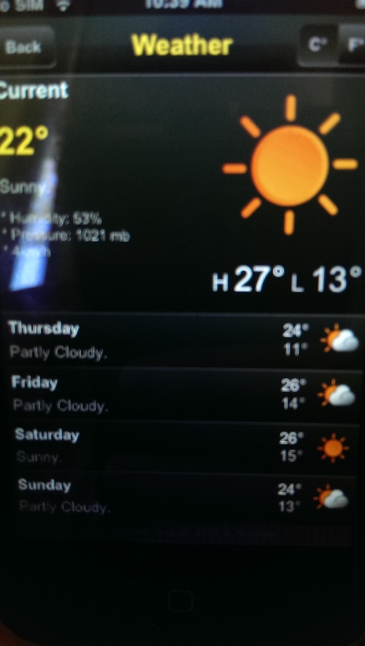

**Weather**

One thing that can really ‘dampen’ a holiday is bad weather. This is why Brisbane Travel Companion includes a Weathersection. The current weather in Brisbane is shown, along a forecast for the next 4 days. The location is set to Brisbane City and cannot be changed to surrounding suburbs. Weather can also be updated by pulling down on the page.

**Extras**

There are also some more features that ‘fill out’ the Brisbane Travel Companion app (see the list at the start of Features). Some of these features offer extra functionality, particularly the Phrases section which translates common English phrases into a variety of languages, while some offer little or no functionality, the Deals tab is totally blank. While these features are not entirely necessary they do offer little extra to Brisbane Travel Companion, increasing its versatility and preventing the need for many separate apps.

**Comparison**

There are a few apps on the market that have similar functionality to this one. This includes TripAdvisor which has a collection of City Guide apps (one for each selected city, not including Brisbane). These apps also provide offline information about a city. The functionality of these City Guide apps far exceeds that of Brisbane Travel Companion, allowing users to browse through all locations (attractions, restaurants, etc) in a city or even find one that is close to their location. Each location also receives a rating based upon user reviews. Each TripAdvisor City Guide user interface is far easier to navigate than Brisbane Travel Companion, as well as a much more appealing graphic design. Brisbane Attractions+ is also a similar app, however it focuses on must attractions. Attractions+ has a hard to use UI, consisting of buttons scattered across the screen that must be pressed in order to know their function (trial and error). While this app does provide good information on attractions in Brisbane, it’s IU and overall graphic design is very poor in comparison to Brisbane Travel Companion

**Summary**

Overall, this Travel app is easy to navigate with information displayed in an easy-to-digest form. The UI is similar to many other apps on the market, with tabs down the bottom leading to each feature within the app (Guide, Map, etc.). Overall the functionality of the app is quite good. However some of the functionality is not particularly useful and makes the app feel less polished, demonstrating the need for perfecting a feature or leaving it out.

**Pros**

* Constant look and feel throughout design
* Easy navigation (tabs and lists)
* A few features with excellent functionality

**Cons**

* While the map shows the user’s location, it is not possible to retrieve directions to a location
* Some ‘filler’ content with limited or no functionality
* Design is quite plain, no ‘oomph’
* No feedback given when the app is loading

**TripAdvisor Hotels Flights Restaurants– By TripAdvisor LLC**

*TripAdvisor Hotels Flights Restaurants* is a free travel planning app available on a variety of platforms, including Android, iOS and Windows Phone. The app is an extension of the well-known TripAdvisor website, featuring all of the same functionality of ‘the world’s largest travel site’ (TripAdvisor, 2013). Similar to the website, through the app users can compare prices for booking hotels, flights and restaurants. All of the destinations are reviewed and ranked in stars by users of the site.

The test device for this app was an iPad 2 running iOS 5.1.1.

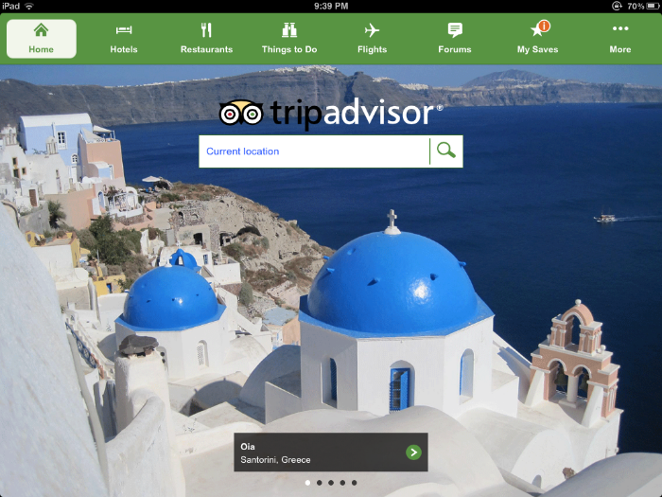

**Features**

* Current Location Search
* Hotels
* Restaurants
* Things To Do
* Flights
* Forums

**Hotels, Restaurants, Flights**

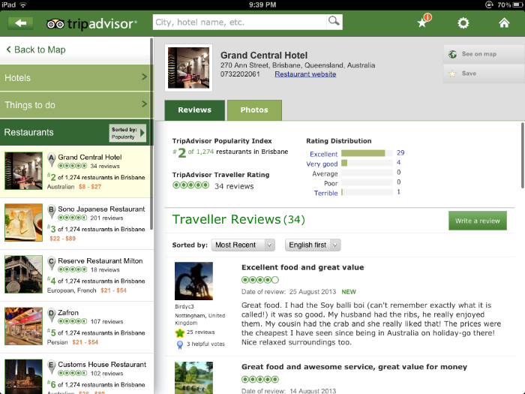One of the most famous and user friendly features of the TripAdvisor website is the ability to see what other users think of a hotel, restaurant or airline. This allows the user to see what others think of a location or service and make a decision accordingly. TripAdvisor even ranks hotels and restaurants based upon user ratings. To post a comment or review on a location/service a user must first create an account with TripAdvisor. This registers them with the app and gives them a profile to use within all apps and the website. All reviews and ratings are based upon user created content.

The app offers many search capabilities for users:

* Hotels – filtering date, price, property type, location and more
* Restaurants – filtering by price, cuisine and location
* Flights – filtering by locations, date, number of travellers and class (eg. economy, etc.)

These make comparing many hotels, restaurants or flights a breeze. Users can also bring up a map of a requested hotel or restaurant, to aid in navigation.

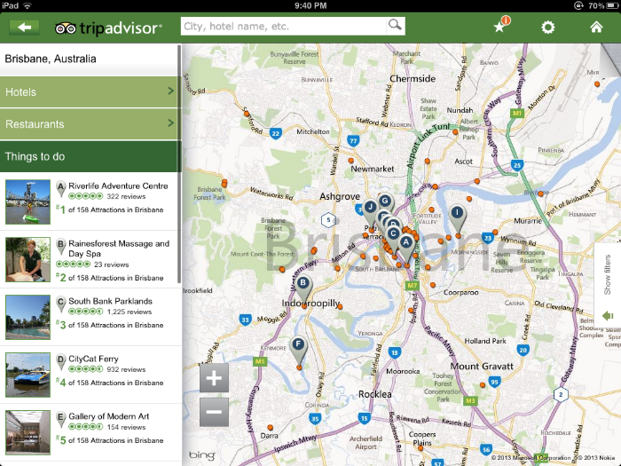**Things To Do**

The Things To Do section of TripAdvisor extends the functionality of the app to include user rating and reviews of activities and attractions within an area. For example, the *Riverlife Adventure Centre* is the #1 attraction in Brisbane. The location of an attraction is also displayed on a map, and can be filtered by type (eg. bar, cultural, etc.). This is a great function and would likely prove useful on a holiday.

**Forums**

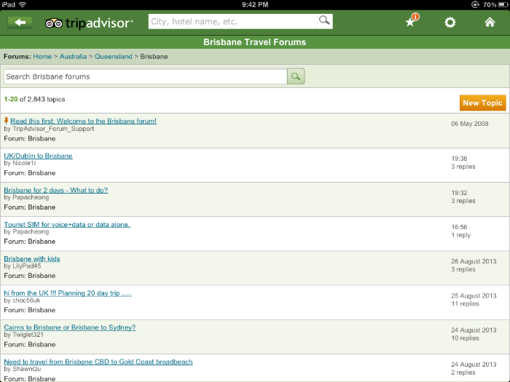TripAdvisor also contains a huge Forums section with user created questions and discussions. Within this sections this is a seemingly endless list of forums for nearly every city on the planet. Due to the large user base of TripAdvisor (including the website), user questions are answered quickly and discussions can be spread over many pages. This ‘encyclopaedia’ of knowledge is invaluable when feeling lost in an unknown, foreign country. It is easy to search through as well, allowing filtering by country, city and search terms. Users within the TripAdvisor community are mostly welcoming and happy to help a fellow traveller.

**Comparison**

As well as TripAdvisor, there are a few other travel planning apps available. One of the most popular ones is KAYAK. KAYAK behaves in an almost identical way to TripAdvisor; allowing users to search through and review locations, book travel and plan their holiday. KAYAK’s user interface is easy to use, however it is not quite as intuitive as TripAdvisor. KAYAK did provide a large amount of feedback to the user, such as providing a loading bar when executing a search. Expedia is also a similar app, however is focuses on just hotels and flights. The biggest difference between Expedia and the other two apps, is the UI. The home screen features infinite scrolling images of hotels on the left (close to your current location) and flights on the right. It is a gorgeous design and immediately draws the viewer in. The functionality of Expedia is more limited than TripAdvisor however.

**Summary**

TripAdvisor is an incredibly polished, well-designed app. Its main functionality lies in comparing hotels, restaurants, flights and attractions, but it also has a *bulging* forum section. It also allows users to engage in a community of other travellers and share their wonderful (or awful) travel experience for others. Navigation is very easy over the various screens, featuring tabbed and list based views. All styling is consistent and centres around green, making each section of the app feel very connected. Overall a near perfect travel app for a wide audience.

**Pros**

* Easy to navigate (includes back button)
* Huge amount of information
* Fast loading times
* Lots of polished functionality
* Constant look and feel, modern
* Very little data is stored on users device (all network accessed)

**Cons**

* Information is user created (unverified)
* User must create an account to post information (app must store sensitive information)
* Totally network dependant, an internet connection may not always be available when on a holiday

**BaconReader for Reddit (Android)**

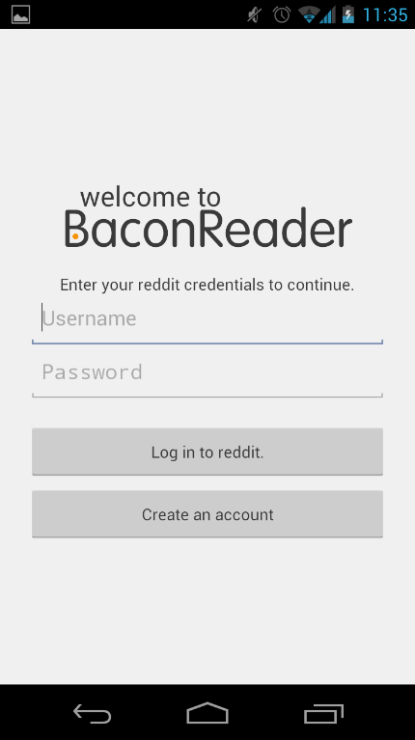  

**Functionalities of Application**

This application allows users to browse through the various “subreddits” (similar to sub-forums in other internet forums) and threads that appear on the website “reddit.com” in a mobile environment. This application also allows users to view the profiles of all members of the Reddit community. On top of these functionalities, users may also post new topics on the various subreddits that are available to the user to browse, as well as post replies to pre-existing Reddit threads.

**Positive Aspects of Application**

* Pleasant aesthetic makes for an easy and enjoyable viewing experience
* Imports almost all of the pre-existing functionality of the Reddit website to mobile devices, without compromising on ease-of-use and the streamlined nature of the website’s original form on personal computer web-browsers
* Little clutter on the screen, which enhances the viewing experience

**Negative Aspects of Application**

* Doesn’t save the sub-reddits that you previously visited, making tracking your viewing history more difficult than it is on personal computers
* Advertising is present in the application, which may annoy some users
* Requires users to log in before they can view sub-reddits and threads, which again may annoy some users

**Tapatalk 2 (iOS)**

Click image for larger version

Name: ImageUploadedByTapatalk 21357226976.410527.jpg
Views: 569
Size: 237.1 KB
ID: 387673 Click image for larger version

Name: ImageUploadedByTapatalk 21357227007.828766.jpg
Views: 518
Size: 278.8 KB
ID: 387674 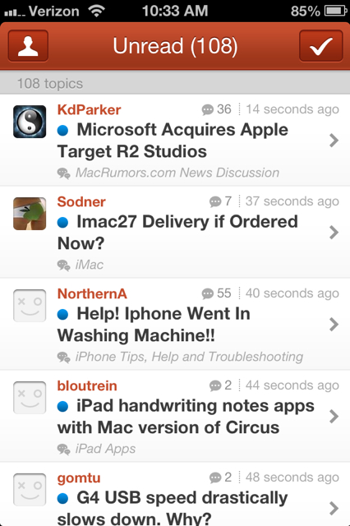

Source of Images: http://forums.macrumors.com/showthread.php?t=1519045

**Functionalities of Application**

This application allows users to browse through and post on various forums on the internet, which are independent of the application itself.

**Positive Aspects of Application**

* Allows users to use many different compatible forums from the internet, independent of the application
* Built from the ground up to optimize the user experience for forum browsing on mobile devices: clean interface, and very little clutter on the screen
* Clean, easy-to-use interface
* Push notification support in order to keep users up-to-date with forums they’re subscribed to
* Instagram support for users to upload pictures from the web service to web forums

**Negative Aspects of Application**

* Various crashing issues noted by some users

**Proboards (Android)**

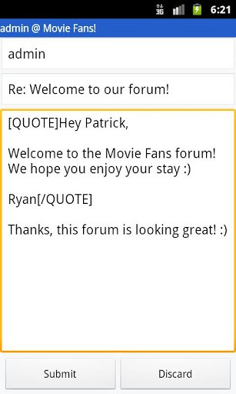 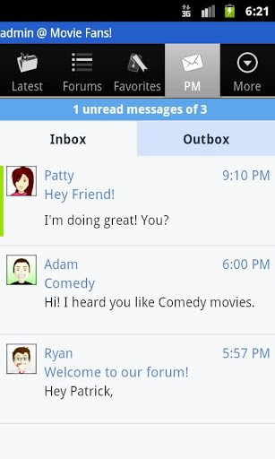

Sources of Images: http://cdn8.staztic.com/app/a/453/453069/proboards-9-4-s-307x512.jpg

http://cdn7.staztic.com/app/a/453/453069/proboards-9-3-s-307x512.jpg

**Functionalities of Application**

This application allows users to browse and post specifically the ProBoard forums, which can only be accessed on mobile devices through this application (apart from going the more difficult route of navigating to the forums through a mobile device web browser). The application also allows users to manage multiple accounts on the same forum and send or read personal messages from other ProBoards users, and

**Positive Aspects of Application**

* Clean interface
* Easy to use
* Allows you to create and read private messages to other users on ProBoards forums
* Built from the ground up to optimize the user experience for forum browsing on mobile devices: clean interface, and very little clutter on the screen

**Negative Aspects of Application**

* Limits users to browsing only ProBoards forum

**User Case Scenarios**

**Creating An Account**

1. From the first time OutGoer is opened the user will be presented with a home screen, giving them the option to create an account (Register).
2. When selected, the screen will prompt the user for their desired username, email and password (including password confirmation). Press the Register button.
3. The user has now joined the OutGoer community!

**Logging In**

1. The user enters their chosen username and password
2. Upon confirmation they will be brought to the main forum page

**Browsing The Forum**

* Tabbed navigation at the bottom of the page
* At the top left of the screen there will be a back arrow to aid in navigation

**Creating A Post/Question**

1. Navigate to any topic page
2. Press the clipboard button at the top right of the screen to start creating a new post )or ask a question)
3. Fill out the required fields on the Create Post page: title, description, map (optional)
4. Confirm the post and publish to OutGoer by pressing the clipboard icon at the bottom of the page

**Settings**

* Once logged in the user can navigate to the settings page from the starting screen
* Users can change their details from this page, as well as viewing the Terms of Service
* They can also delete their account from this page

**Information Architecture**

Posts and user information will be stored in an SQL database. Each table within the database will have a separate function, with one serving a different topic (nightlife, food, etc.). A separate table will be used to store user information, with passwords stored in a hashed format.

Some information will be stored on the user’s phone, to aid in usability. For example: remembering login details. Information retrieved from the database will be in raw text format and formatted client side, reducing data usage and loading times.

OutGoer can be closed completely, or let open (minimised/tray) to continue receiving notifications from a question or post the user is involved in.

This application is network dependant, meaning it is not functional is there is no connection to the internet. This is done in order to save space on the user’s device.

**Story Board**

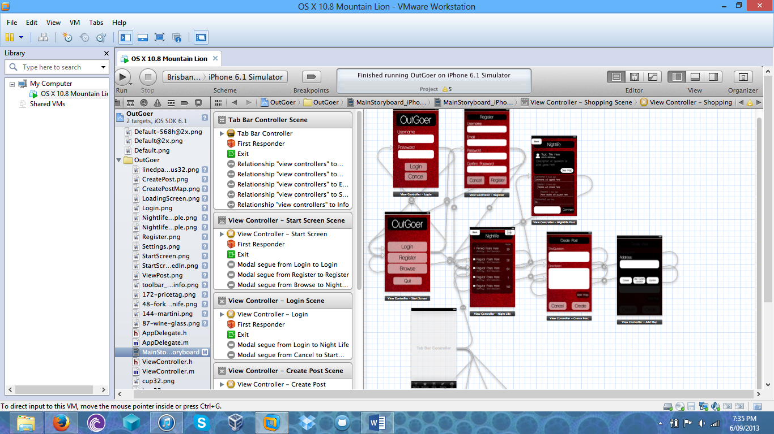The following storyboard shows the flow of the proposed app: Outgoer. For more information please see the attached XCode project, PNG images and Photoshop Documents. This example shows a user navigating through the nightlife topic. Each topic will feature the exact same functionality. Other topics are not included in this storyboard to aid in readability and prevent clutter. Some icons used are by Glyphish (http://glyphish.com).